Try to map the ERD and then create DB with the following Constraints:

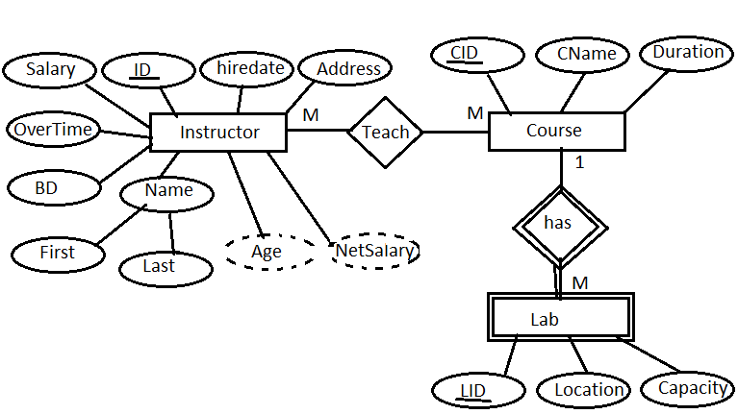

* All Ids are Identity
* All Foreign keys are not identity
* All foreign keys have cascade rule on delete and update
* Age and Netsalary are calculated attributes but it will be on instructor table creation
* Netsalary=salary+overtime
* Age=current year – birthdate year
* Address has only cairo or alex value
* All salaries in the range from 1000 to 5000
* Salary has a default value = 3000
* Overtime is unique
* Capacity of each lab under 20 seats
* Lab is weak entity
* Hiredate has a default value= current system data
* Duration of each course is unique

Instructor (**ID**, fName, lName, BoD, OverTime, Salary, hiredate, Address)

Teach (**ID, CID**)

Course (**CID**, CName, Duration)

Lab (**CID, LID**, Location, Capacity)